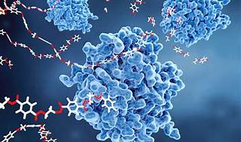

Explore

Certainly! In a nutshell, **enzyme technology** is a subfield of biotechnology that focuses on utilizing enzymes as **biocatalysts** to develop new processes for manufacturing both bulk and high-value products. [These products span various domains, including food (e.g., bread, cheese, beer, vinegar), fine chemicals (such as amino acids and vitamins), and pharmaceuticals1](https://bing.com/search?q=enzyme+in+tech+definition).

Here are **five free reference links** where you can learn more about enzyme technology:

1. [**Introduction to Enzyme Technology**](https://microbenotes.com/enzyme-technology/): This resource provides an overview of enzyme technology, covering production, isolation, purification, and applications of enzymes[2](https://microbenotes.com/enzyme-technology/).
2. [**Enzyme Technology (Chapter 5)**](https://www.cambridge.org/core/books/biotechnology/enzyme-technology/EC1477D4B69ADDAFB06689D08D384B90): Dive deeper into the catalytic nature of enzymes and their specificity in this chapter[3](https://www.cambridge.org/core/books/biotechnology/enzyme-technology/EC1477D4B69ADDAFB06689D08D384B90).
3. [**Enzyme Technology: Application and Commercial Production of Enzymes**](https://www.biologydiscussion.com/enzymes/enzyme-technology/enzyme-technology-application-and-commercial-production-of-enzymes/10185): Explore the practical aspects of enzyme production and use for the benefit of humankind[4](https://www.biologydiscussion.com/enzymes/enzyme-technology/enzyme-technology-application-and-commercial-production-of-enzymes/10185).
4. **Enzymes in Biotechnology**: This article delves into the role of enzymes in biotechnological applications, including enzyme engineering and recombinant DNA technology.
5. **Enzyme Technology: An Overview**: Read this comprehensive overview that covers enzyme technology’s significance, applications, and future prospects.

Happy learning! 🧪🔬